

**Helwan University**

**Faculty of Computers and Artificial Intelligence**

**Software Engineering Program**

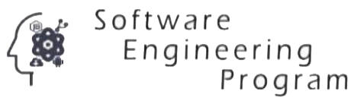

[MediBooki Healthcare System]

A graduation project dissertation by:

[ Mohamed Ali GadAlhak Hassan ( 20201871 ) ]

[ Assem Mohamed AhmedSamy Mohamed ( 20201836 ) ]

[ Pola Osama Aziz ( 20201823 ) ]

[ Ahmed Salah Mohammed ( 20201803 ) ]

[ Ahmed Waleed Abdullah Ahmed ( 20201815 ) ]

[ Eslam Sabry Hassan ( 20201849 ) ]

Submitted in partial fulfilment of the requirements for the degree of Bachelor of Science in Computers & Artificial Intelligence, at the Software Engineering Program, the Faculty of Computers & Artificial Intelligence, Helwan University

Supervised by:

**[ Assc. Prof. Mohamed Marie ]**

June 2023